Author：Phan Le Tuan

Due Date：October 2, 2024

Golflick Website

CONTENT OF OPERATION

Revision History

|  |  |  |  |  |  |
| --- | --- | --- | --- | --- | --- |
| Date | Version | Author | Description | Reviewer | Date Review |
| October 2, 2024 | 1.0 | Phan Le Tuan | Create and fill content | Phan Le Tuan | October 2, 2024 |
|  |  |  |  |  |  |
|  |  |  |  |  |  |

**TABLE OF CONTENTS**

1. INTRODUCTION 2

1.1 Purpose 2

1.2 References 2

1.3 Audience 2

2. CURRENT SYSTEM AND DIFFICULTIES 2

2.1 Goal, audience and scope 2

2.2 Policy and constraint 2

2.3 Description of current system 2

2.4 Current user and stakeholder 2

2.5 Environment supports the current working 2

3. THE DESIRE CHANGES 2

3.1 These changes are expected 3

3.2 Detailed description of the changes 3

4. PROPOSED SYSTEM 3

4.1 Goal and audience 3

4.2 Policy and constraints 3

4.3 Description of proposed system 3

4.4 Business Model Canvas 3

4.5 User and stakeholder in the future 3

4.6 Suggest a supportive environment. 4

4.7 Quality attributes 4

5. SUMMARIZES THE IMPACT 4

# **INTRODUCTION**

## **Purpose**

* The Concept of Operations (ConOps) document provides a comprehensive understanding of how the software will function and meet the needs of its users. It outlines the objectives, system capabilities, user roles, operational processes, constraints, and decision-making considerations.
* Document serving as a foundation for system design and facilitating effective communication and collaboration among stakeholders. It ensures that the Golfick system is developed and deployed successfully, meeting the expectations and requirements of its users and operational environment.

## **References**

null

## **1.3 Audience**

|  |  |  |
| --- | --- | --- |
| **Intended Audience** | **Name** | **Reading Suggestion** |
| Developer & PM | Phan Lê Tuấn | All Sections |

# **2. CURRENT SYSTEM AND DIFFICULTIES**

## **2.1 Goal, audience and scope**

* **Goal**: Provide a convenient and user-friendly platform have all golf products with some special offers to purchase and refer to
* **Audience**: user who need a place to buy golf stuff, system administrators.
* **Scope**: Consist of shopping cart, purchase with card simulation, blog page for product news, contact page for contacting with administrator and user, a list of product have some special offers, filter product with category.

## **2.2 Policy and constraint**

* Policy: Cancellation Policy, Payment Policies, Regulatory Compliance
* Constraint:
* The hotel staff should accurately provide different room types (e.g., standard, deluxe, suite)
* Security and reliability are paramount when handling payment transactions.
* The system needs to handle pricing calculations based on factors like room type, seasonality, length of stay, and any discounts or promotions.
* Customer response times need to be quick

## **2.3 Description of current system**

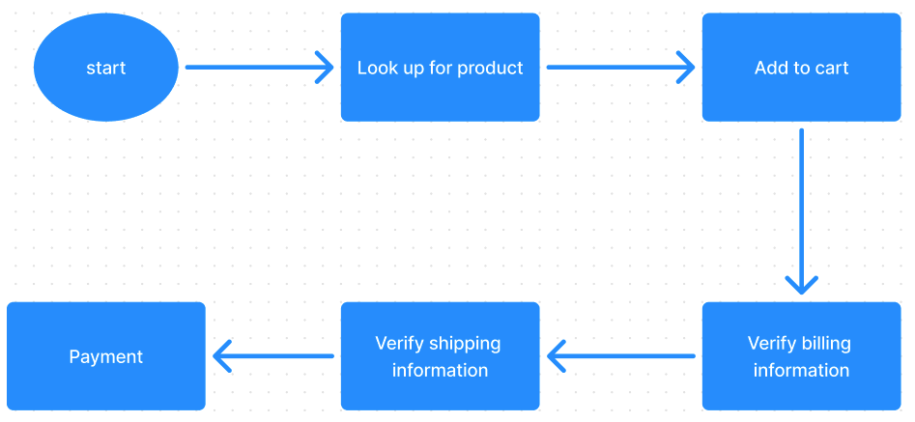

1. Look up for product : Initially, users will looking for the product that they want to purchase or just for the review by using searching feature on website
2. Add to cart : Users can choose their favourite product to cart for holding the item and preparing for the purchase.
3. Verify billing information : To purchase items, users need to verify their own information, item information and price.
4. Verify shipping information : This essential step will help users verify their shipping location to make sure their product will be delivered correctly
5. Payment : To purchase products on the final step, users will choose payment method to pay for their items.

## **2.4 Current user and stakeholder**

|  |  |
| --- | --- |
| **Role** | **Responsibility** |
| User | * The user's responsibility is to search and select suitable hotel room options according to their needs. * They need to provide accurate personal information when booking and making payments. * Users also have the responsibility to read and understand the hotel's terms and conditions, including booking cancellation policies. |
| Administrator | * Have permission to edit products * Analyze income & outcome |

## **2.5 Environment supports the current working**

Totally done manually

# **3. THE DESIRE CHANGES**

## **3.1 These changes are expected**

## **3.2 Detailed description of the changes**

# **4. PROPOSED SYSTEM**

## **4.1 Goal and audience**

## **4.2 Policy and constraints**

* Policy: The system must adhere to strict policies regarding user data privacy, secure payment processing, and regulatory compliance. Cancellation and refund policies must be transparent and easily accessible to users.
* Constraints: The system should ensure high reliability and security, particularly during payment transactions. It must handle complex pricing algorithms based on room type and should provide real-time availability updates. The system also needs to maintain quick response times and be scalable to handle peak loads.

## **4.3 Description of proposed system**

## **4.4 Business Model Canvas**

## **4.5 User and stakeholder in the future**

|  |  |
| --- | --- |
| **Role** | **Responsibility** |
| User | Search and purchase product, manage personal information, view purchase history and make secure payments. |
| Admin | Oversee the entire system, manage products, monitor system performance, and ensure compliance with policies. |

## **4.6 Suggest a supportive environment.**

## **4.7 Quality attributes**

|  |  |  |
| --- | --- | --- |
| **No.** | **Quality attributes** | **Description** |
| 1 | Security | Ensures protection against data breaches and fraud, particularly during payment transactions. |
| 2 | Usability | Provides an intuitive and user-friendly interface to enhance the booking experience for all users. |
| 3 | Performance | Maintains quick response times and handles large volumes of transactions efficiently. |
| 4 | Maintainability | Facilitates easy updates and maintenance to ensure the system remains up-to-date and functional. |
| 5 | Flexibility | Offers flexibility to accommodate different types of bookings and customer preferences. |

# **5. SUMMARIZES THE IMPACT**